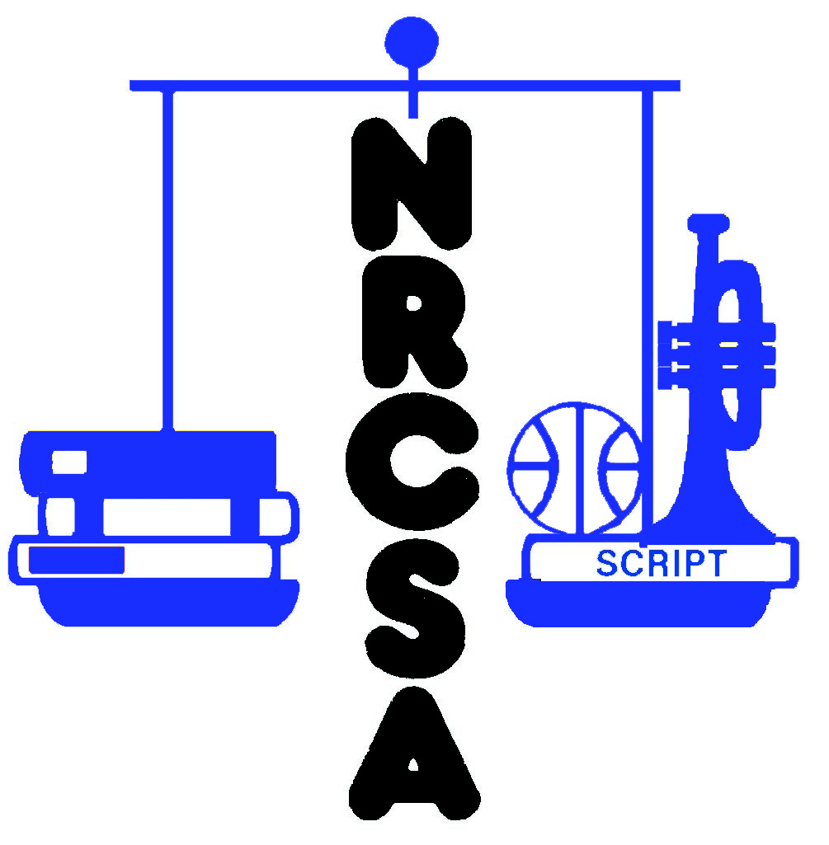
Nebraska Rural Community Schools Association
2023-24 Individual Membership Form

PLEASE PRINT OR TYPE CLEARLY

Name:

Organization:

Address:

City: |  | St: |  | Postal Code:

Phone Number: |  | Fax Number:

e-mail:

Please include a check for $35.00 payable to NRCSA

Send dues and registration form to:

NRCSA
455 S 11th St, Suite B
Lincoln, NE 68508

