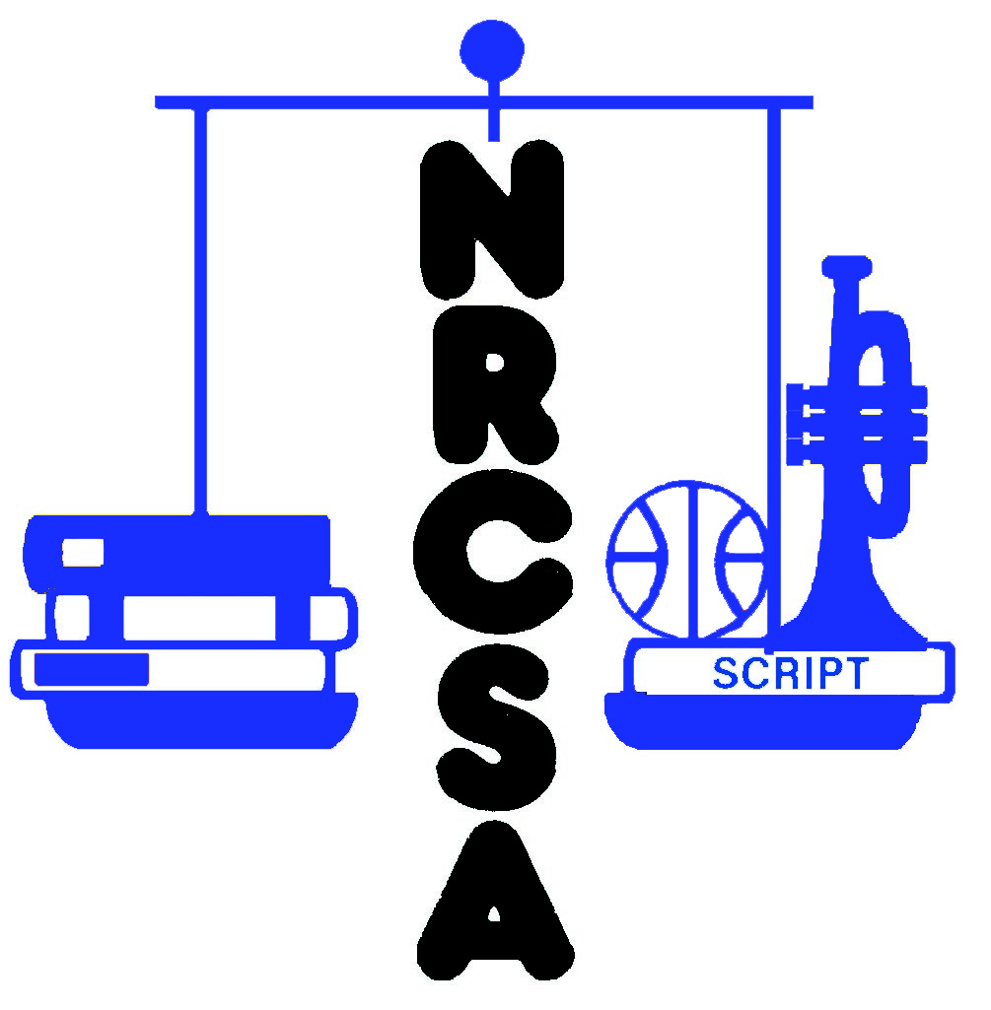
Nebraska Rural Community Schools Association
2023-24 Membership Form

PLEASE PRINT OR TYPE CLEARLY

School District/ESU Name:

Address:

City: |  | St: | NE | Postal Code:

Phone Number: |  | Fax Number:

Administrator Name:

Administrator e-mail:

Administrator Cell Phone:

ADMINISTRATOR, BOARD MEMBERS, AND OTHER CONTACTS (Optional)

Name Title e-mail

Please include a check for $850.00 payable to NRCSA
Send dues and registration to:

NRCSA
455 S. 11th St, Suite B
Lincoln, NE 68508

