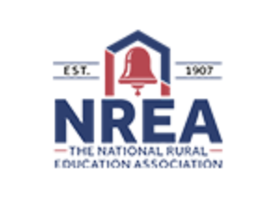
NREA Discounted Membership (Through NRCSA)
2023-24 Membership Form

Instructions:
Complete this form if your superintendent or district wants to become a member of the National Rural Education Association (NREA). NRCSA as a state affiliate of the NREA, is able to offer members a twenty-five (25%) discount on membership to the NREA. Please complete the form entirely, and submit to the NRCSA office via, mail, e-mail, or fax.

School District Name:

Address:

City: |  | St: | NE | Postal Code:

Phone Number: |  | Fax Number:

Administrator Name:
Administrator e-mail:

Type of Membership:

There are two different membership options. The discounted individual membership allows one (1) person to join the NREA at a cost of $75.00. The discounted school district membership allows a maximum of 7 people (board members or other staff) to join the NREA at a cost of $300.00.

Contact 1 Name: |  | Title: |  | e-mail:
Contact 2 Name: |  | Title: |  | e-mail:
Contact 3 Name: |  | Title: |  | e-mail:
Contact 4 Name: |  | Title: |  | e-mail:
Contact 5 Name: |  | Title: |  | e-mail:
Contact 6 Name: |  | Title: |  | e-mail:
Contact 7 Name: |  | Title: |  | e-mail:

Please include a SEPARATE check for the membership fees payable to the NREA.
Send dues and registration form to:

NRCSA
455 S. 11th St, Suite B
Lincoln, NE 68508

