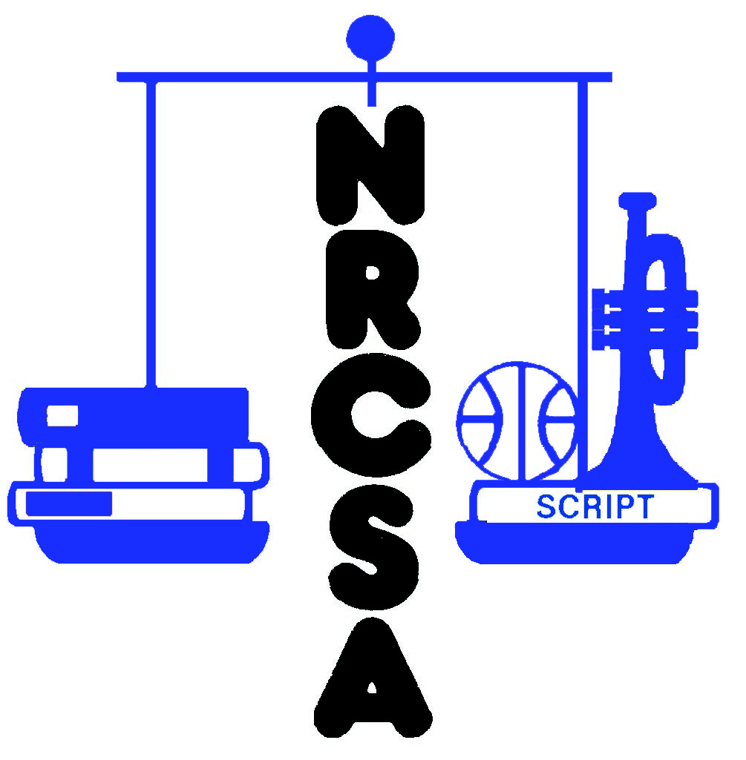Nebraska Rural Community Schools Association

**NRCSA Spring Conference**

**March 19 - 21, 2025**

**Crowne Plaza & Younes North Convention Center**

**Registration Form**

|  |  |
| --- | --- |
| School or Institution Name: |  |

|  |  |  |  |
| --- | --- | --- | --- |
| District Phone No: |  | Contact Person: |  |

|  |  |  |  |  |  |
| --- | --- | --- | --- | --- | --- |
| Address: |  | City: |  | Zip: |  |

|  |  |
| --- | --- |
| Contact Person e-mail Address: |  |
|  |  |

**_____________________________________________________________________________________**

**Pre-Conference Leadership Seminar – 10:00 AM Wednesday, March 19, 2025**

**Seven Habits of Highly Effective People** *brought to you by:*

|  |  |  |
| --- | --- | --- |
| Registrant’s Full Name | Name for Nametag | Wednesday Lunch  3-19-25 |
| Example  John Smith | John | X |
|  |  |  |
|  |  |  |
|  |  |  |
|  |  |  |
|  |  |  |

*This pre-conference leadership seminar by FranklinCovey is free for NRCSA members but space is limited to the first 150 registrants.*

**_____________________________________________________________________________________**

**_____________________________________________________________________________________**

**2025 NRCSA Spring Conference – March 20 & 21, 2025**

Please register ONLY for the meals the registrant will attend

**Note: Meal Fees are included in Conference Fees**

|  |  |  |  |  |  |  |
| --- | --- | --- | --- | --- | --- | --- |
| Registrant’s Full Name | Name for Nametag | Conference Fees:  $220.00 – Member  $360.00 – Non-Member | Thursday Lunch  3-20-25 | Thursday Dinner  3-20-25 | Friday Brunch  3-21-25 | Total |
| Example  John Smith | John | $220.00 | X | X | X | $220.00 |
|  |  |  |  |  |  |  |
|  |  |  |  |  |  |  |
|  |  |  |  |  |  |  |
|  |  |  |  |  |  |  |
|  |  |  |  |  |  |  |
|  |  |  |  |  |  |  |
|  |  |  |  |  |  |  |
|  |  |  |  |  |  |  |
|  |  |  |  |  |  |  |
|  |  |  |  |  |  |  |

|  |  |  |  |  |  |  |  |
| --- | --- | --- | --- | --- | --- | --- | --- |
| Spouses/Guests Additional Meals for Spouses or Guests | | | | $30.00 | $25.00 | $23.00 | Total |
|  |  | No Conf Fee Needed | No Conf Fee Needed |  |  |  |  |
|  |  | No Conf Fee Needed | No Conf Fee Needed |  |  |  |  |
|  |  | No Conf Fee Needed | No Conf Fee Needed |  |  |  |  |

|  |
| --- |
|  |

Make Checks Payable to: **NRCSA Total Enclosed:**

Mail or Fax Registrations To:

**NRCSA Spring Conference**

**440 S. 13th St, Ste B**

**Lincoln, NE 68508**

NO REFUNDS AFTER March 14

**Fax: (402) 476-7740**

**Or register on-line at: *www.nrcsa.net***

**_____________________________________________________________________________________**